DON BOSCO INSTITUTE OF TECHNOLOGY KURLA, MUMBAI

A PROJECT REPORT ON

**“E-BachatGat”**

SUBMITTEDBY:

**GANESH MASTUD (38)**

**AFIF SHAIKH (62)**

**PRABODH SHEWALKAR (65)**

UNDER THE GUIDENCES OF:

**Vaishali Kavathekar**



**DEPARTMENT OF INFORMATION TECHNOLOGY**

**(2019-2020)**

# CERTIFICATE

This is to certify that the project entitled **“****E-BachatGat”** is a bonafide work of **GANESH MASTUD (38),** **AFIF SHAIKH (62), PRABODH SHEWALKAR (65)** submitted to the University of Mumbai in partial fulfillment of the requirement for the award of the degree of “**TEIT”** in **“Internet Programming”**.

(GUIDE SIGNATURE) (HOD SIGNATURE)

# Dissertation Approval Certificate

This project report entitled website on E-BachatGat by Ganesh Mastud, Afif Shaikh and Prabodh Shewalkar is approved for the degree of Bachelor of Engineering in Information Technology.

Examiners

1.---------------------------------------------

Name: -

Date: -

Place: -

# Declaration

I declare that this written submission represents my ideas in my own words and where others' ideas or words have been included, I have adequately cited and referenced the original sources. I also declare that I have adhered to all principles of academic honesty and integrity and have not misrepresented or fabricated or falsified any idea/data/fact/source in my submission. I understand that any violation of the above will be cause for disciplinary action by the Institute and can also evoke penal action from the sources which have thus not been properly cited or from whom proper permission has not been taken when needed.

--------------------------------------

(Ganesh Mastud – 38

Afif Shaikh – 62

Prabodh Shewalkar – 65)

Date:

ABSTRACT

CONTENTS

# Introduction

* 1. Problem Statement
  2. Scope of the Project
  3. Current Scenario
  4. Need for the Proposed System

# Review of Literature

* 1. Summary of the investigation in the published papers/web sites / existing application’s

# Analysis and Design

* 1. Methodology/Analysis Circuit diagram of hardware and explanation
  2. System architecture /Design

# Implementation

* 1. Responsive Web Designing/ Layout Designing
  2. HTML5, CSS3
  3. PHP MYSQL
  4. Ajax/Json
  5. Web Services
  6. Web Security

**5 Results and Discussion**

**6 References**

**7 Conclusion**

**1.Introduction:**

**1.1 Problem Statement:**

Small-scale businesses like BachatGat are unknown to cities and don’t have enough reach to urban areas.

**1.2 Scope of the Project:**

This website is targeted to small-scale businesses. To provide them an Online platform to sell their products.

**1.3 Current Scenario:**

We have created a website for multiple vendors and multiple users.

The customer can buy products and also the vendor can add more products and edit the existing products.

**1.4 Need for the Proposed System:**

As BachatGat are not known by that much people as it should supposed to be and there are no websites which sells products of different BachatGats. Therefore our project/website will resolve these problems

**Implementation**

**1.Database Connectivity/Nodejs**

1.MySQL

* A module MySQLx was installed and connection is made with database.

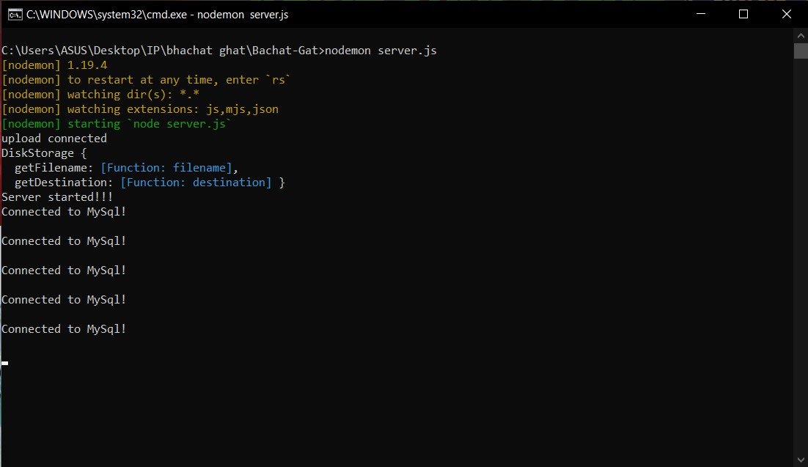

**2.Responsive**

Description

Our website is responsive, that means it can viewed on different screens

Code

@media screen and (max-width: 1000px) {

.topnav .search-container {

float: none;

}

.topnav a, .topnav input[type=text], .topnav, .search-container{

float: none;

display: block;

text-align: left;

width: 100%;

margin: 0;

border-radius: 0px;

}

.cart_and_user, .buts{

float: none;

text-align: left;

border-radius: 25px 25px 25px 25px;

margin: 0;

}

.topnav input[type=text] {

padding: 6px;

margin-top: 8px;

font-size: 17px;

border: none;

}

}

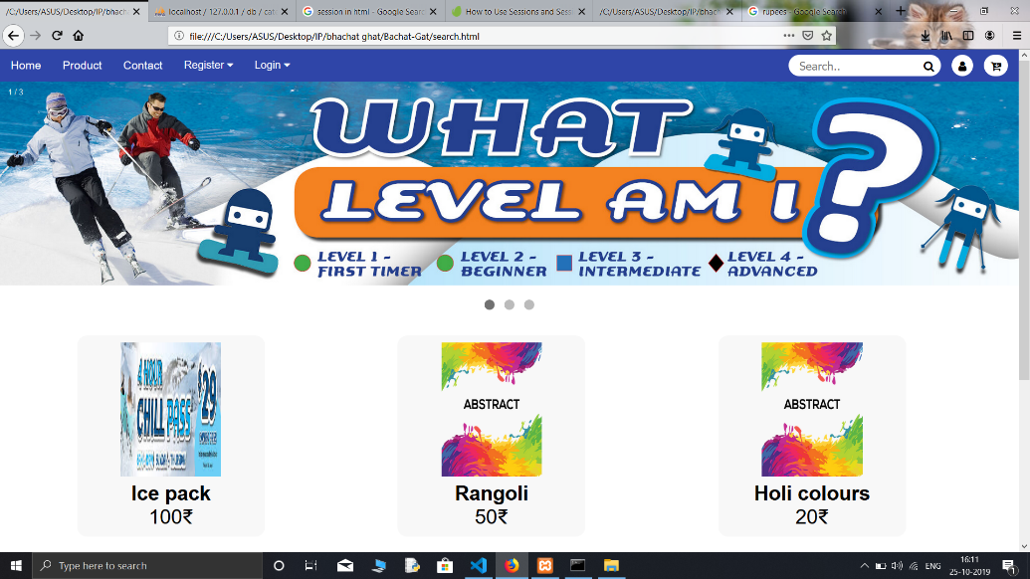

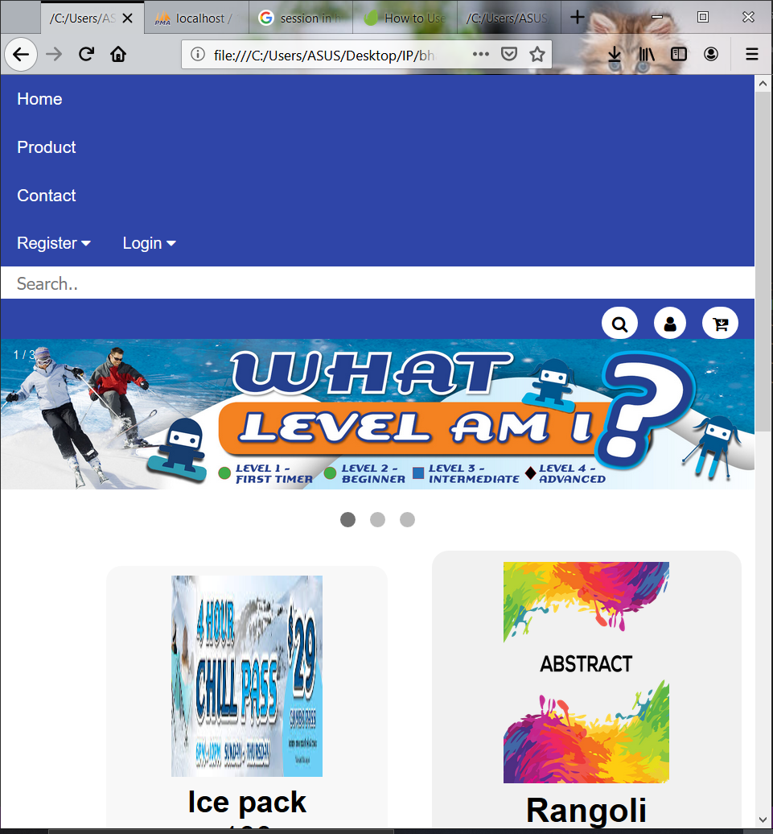

**3.Ajax**

Description

For AJAX implementation, we have used Home Page of our website. Once the homr page gets loaded the products image are fetched using AJAX.

Code

var express = require('express');

var router = express.Router();

// MySQL Connection

var mysql = require('mysql');

var connection = mysql.createConnection({

host: 'localhost',

user: 'root',

password: '',

database: 'bg'

});

connection.connect(function(err) {

if (!err) {

console.log('Connected to MySql!\n');

} else {

console.log('Not connected to MySql.\n');

}

});

router.post('/', (req, res) =>{

console.log("I got called images");

let arr = [];

//Query to select the tuple of the user

connection.query('SELECT location FROM images', function (error, result) {

if (error)

{

console.log("error");

res.sendStatus(400);

}

else

{

var data = result;

console.log(data)

console.log(result[0].location);

for(var i=0,len=data.length;i<len;i++){

arr.push(data[i].location);

}

//User exists

res.status(200).send(arr);

}

});

});

module.exports=router;

Output

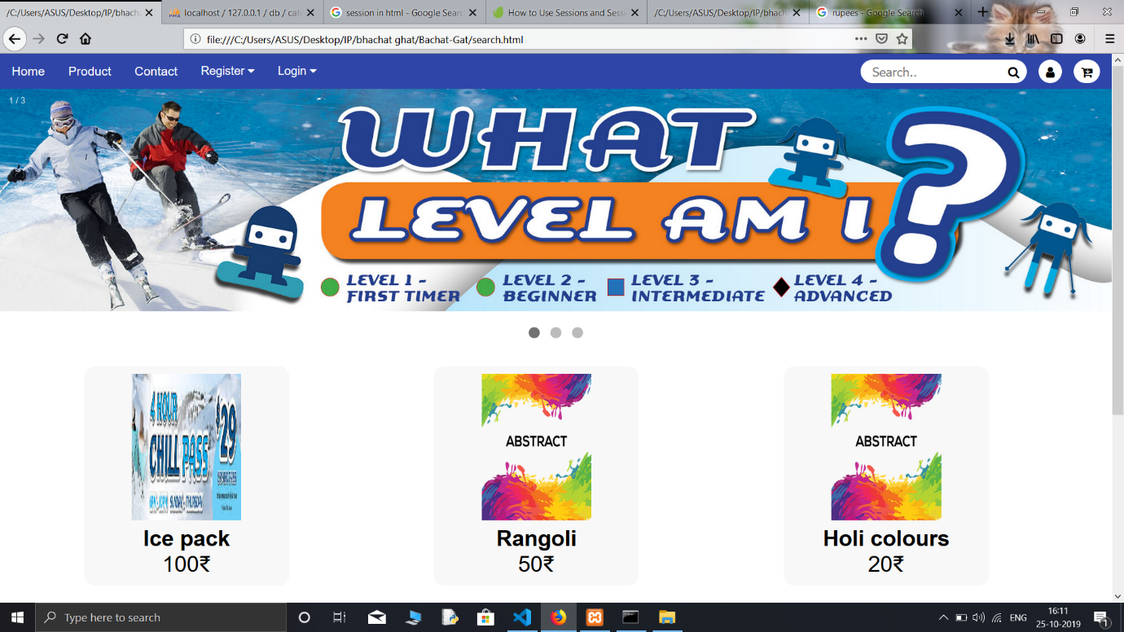

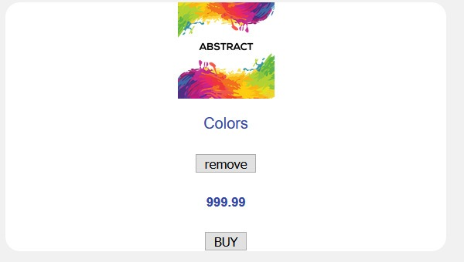

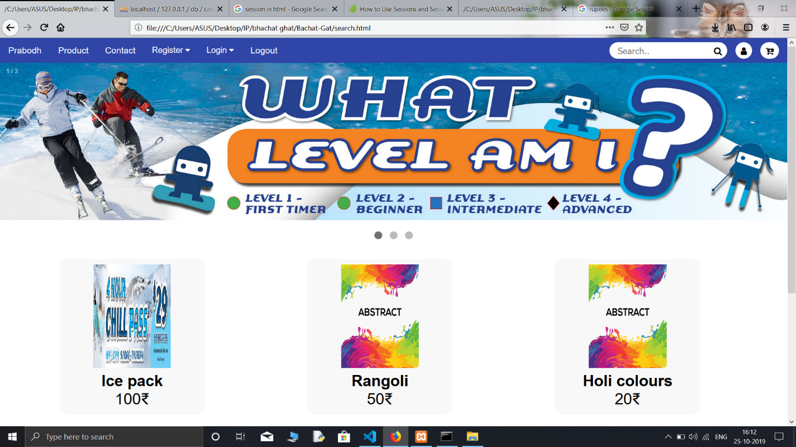

**4.Form Validation**

Description:

For form validation we have used the login page of our website. Once the user has filled the required fields in the register form the data will be sent to the server using AJAX. Validation is performed on the data entered by user. If any field is empty then user will be alerted.

Code

<script type=text/javascript>

function loadDoc(){

var username = document.getElementById("username").value;

localStorage.setItem("textvalue",username);

var password = document.getElementById("password").value;

var message;

var xhr = new XMLHttpRequest();

var url = "http://localhost:4000/U_login/";

xhr.open("POST", url, true);

xhr.setRequestHeader('Content-Type','application/json');

xhr.send(JSON.stringify({"username":username,"password":password}));

//document.getElementById("w").innerHTML= "abcdef";

xhr.onload = function () {

if (this.status == 200) {

alert("Successful Login!!");

window.location.href = "search.html";

//arr.push(this.responseText);

}

else if (this.status == 400) {

message = alert(this.responseText);

//document.write("123456s");

alert(message.message);

}

else {

alert("incorrect request");

}

}

}

</script>

Output

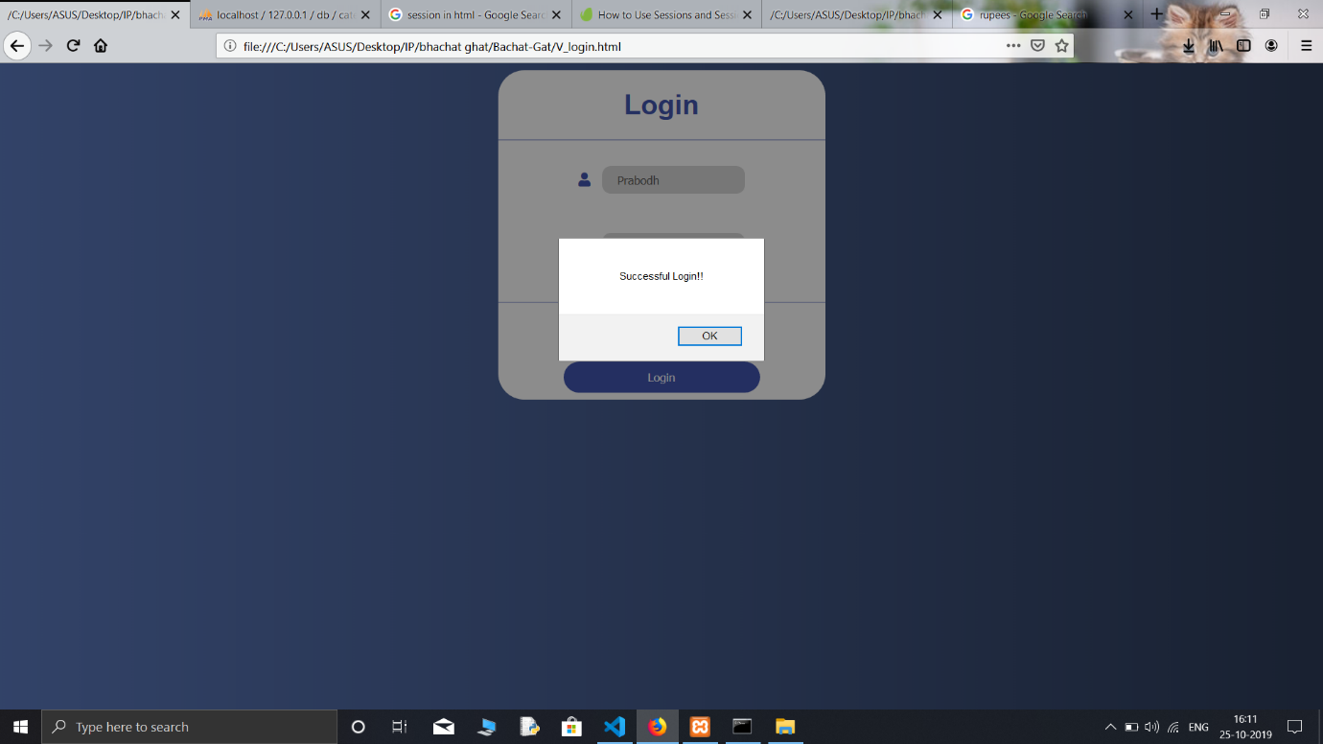

**5.Animation**

We have used animation in image slider

Code

//CSS

* Fading animation */

.fade {

-webkit-animation-name: fade;

-webkit-animation-duration: 1.5s;

animation-name: fade;

animation-duration: 1.5s;

}

@-webkit-keyframes fade {

from {opacity: .4}

to {opacity: 1}

}

@keyframes fade {

from {opacity: .4}

to {opacity: 1}

}

//HTML

<div class="slideshow-container">

<div class="mySlides fade">

<div class="numbertext">1 / 3</div>

<img src="1 (1).jpg" style="width:100%">

<div class="text"></div>

</div>

<div class="mySlides fade">

<div class="numbertext">2 / 3</div>

<img src="1 (2).jpg" style="width:100%">

<div class="text"></div>

</div>

<div class="mySlides fade">

<div class="numbertext">3 / 3</div>

<img src="1 (3).jpg" style="width:100%">

<div class="text"></div>

</div>

**//output**

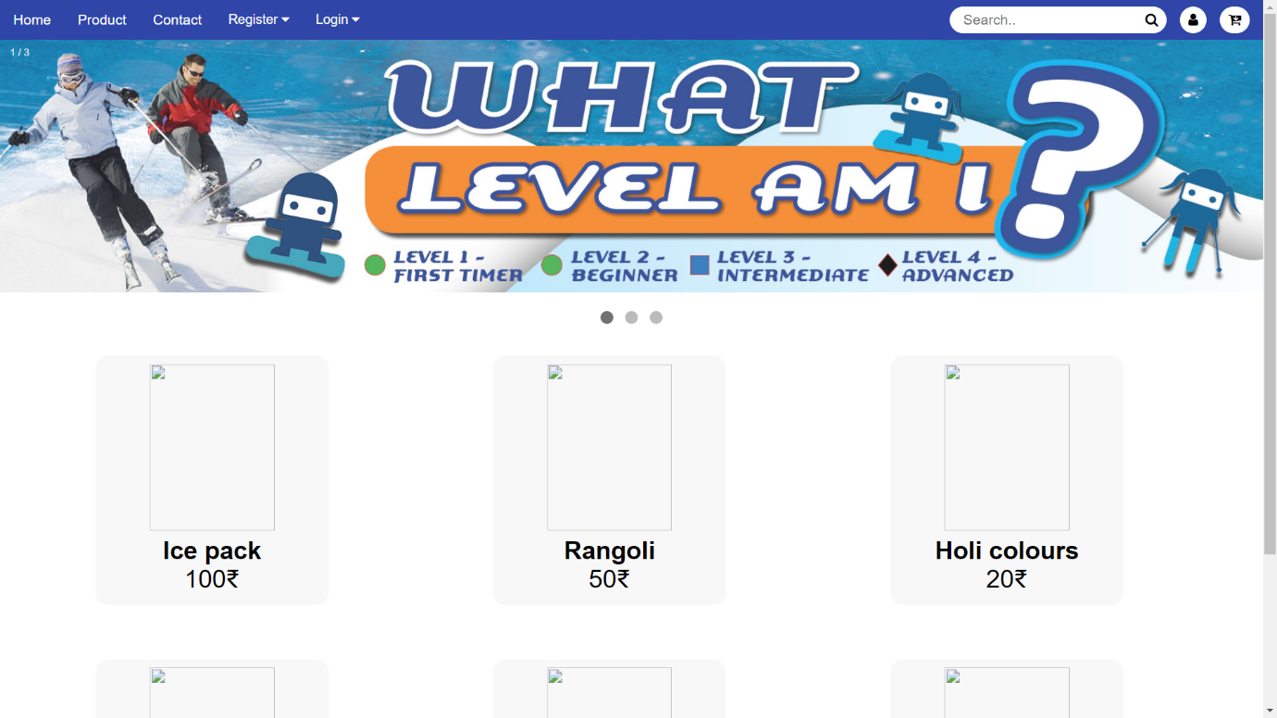

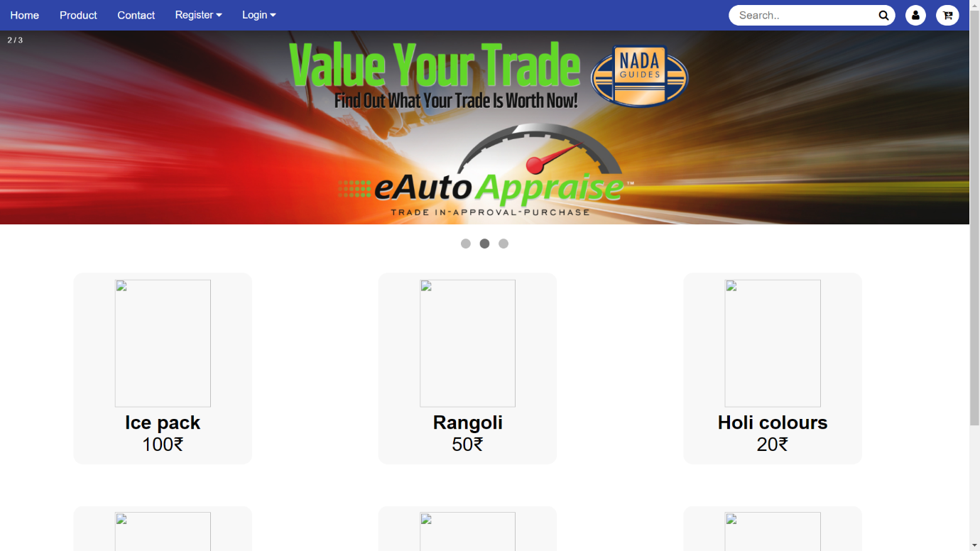

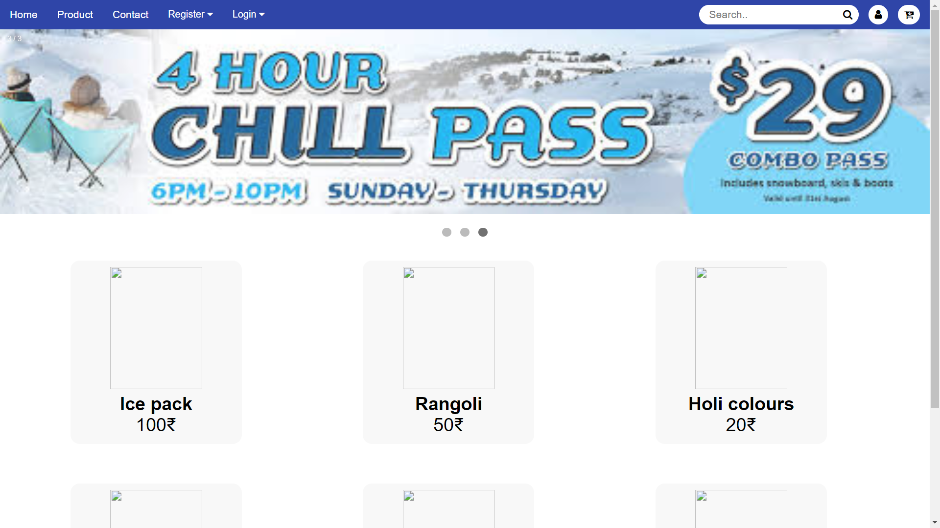

**Conclusion:**

Our website will boost the business of BachatGats and encourage others to start their own business. This website will also be beneficial for customers as they can purchase handmade goods from our online ecommerce website.